Use of AI
Declaration:
I acknowledge the use of ChatGPT to help me understand certain concepts and help refine my sentences. The output was modified by applying the learned concepts and I checked the accuracy of any information, data or sources generated by cross checking with online sources.

Justification:
I used ChatGPT to help me better understand some of the concepts used in this assignment such as “the Golden thread” and functionalities of Tableau as well. This helped me to apply these concepts correctly in my analysis. I also used ChatGPT to improve formality of words and help my writing, by refining sentences and vocabulary. This helped make my explanations clearer and more brief. Overall, I found ChatGPT useful as a support tool for learning unfamiliar concepts and improving the quality of my writing.
Below I have attached screenshots for example.
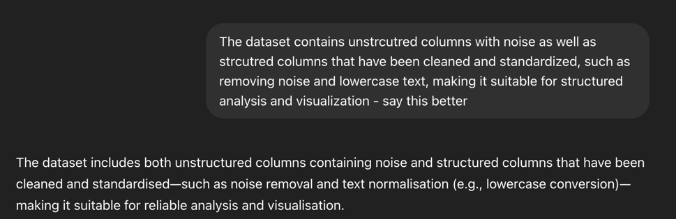
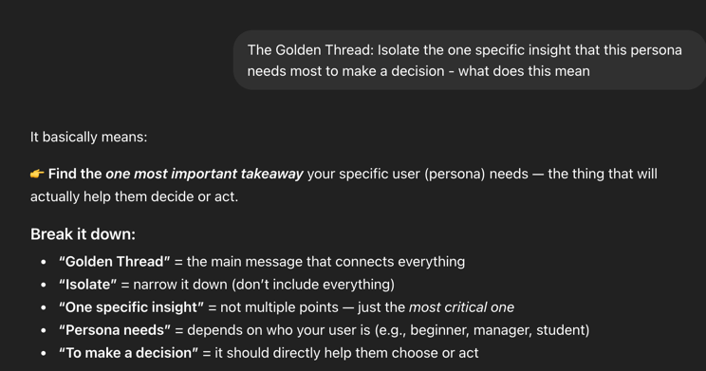

Link to transcript:
https://chatgpt.com/share/69d4f805-d694-83a1-aa7e-0e5c4392b403

(Next page is the transcript attached)

